How to Create Printed Phantom with Iohexol Ink

1. Create the ink.
   1. Mix 2/3 ink with 1/3 300mg/mL iohexol solution in a clean container.
   2. Properly label used syringes and container for future use
2. Using a new syringe, fill a refillable cartridge (any color) with the iohexol ink solution.
   1. As a note, the small cartridges can fit a maximum of 17mL.
   2. Be sure to remove the extra cartridge cap or tape which covers the air intake on the cartridge. This allows air to flow into the cartridge during printing, and failing to do so can render the cartridge useless.
3. Carefully place the cartridge in the printer.
4. Print several large swatches of color using only the cartridge with the iohexol ink solution until the ink solution prints completely. This will clear out any residual ink left in the tubes of the printer.
   1. To print with only a single cartridge, first create a new image in GIMP
   2. Next, fill the image with a single color using the bucket tool. (tools > paint tools > bucket fill)
   3. 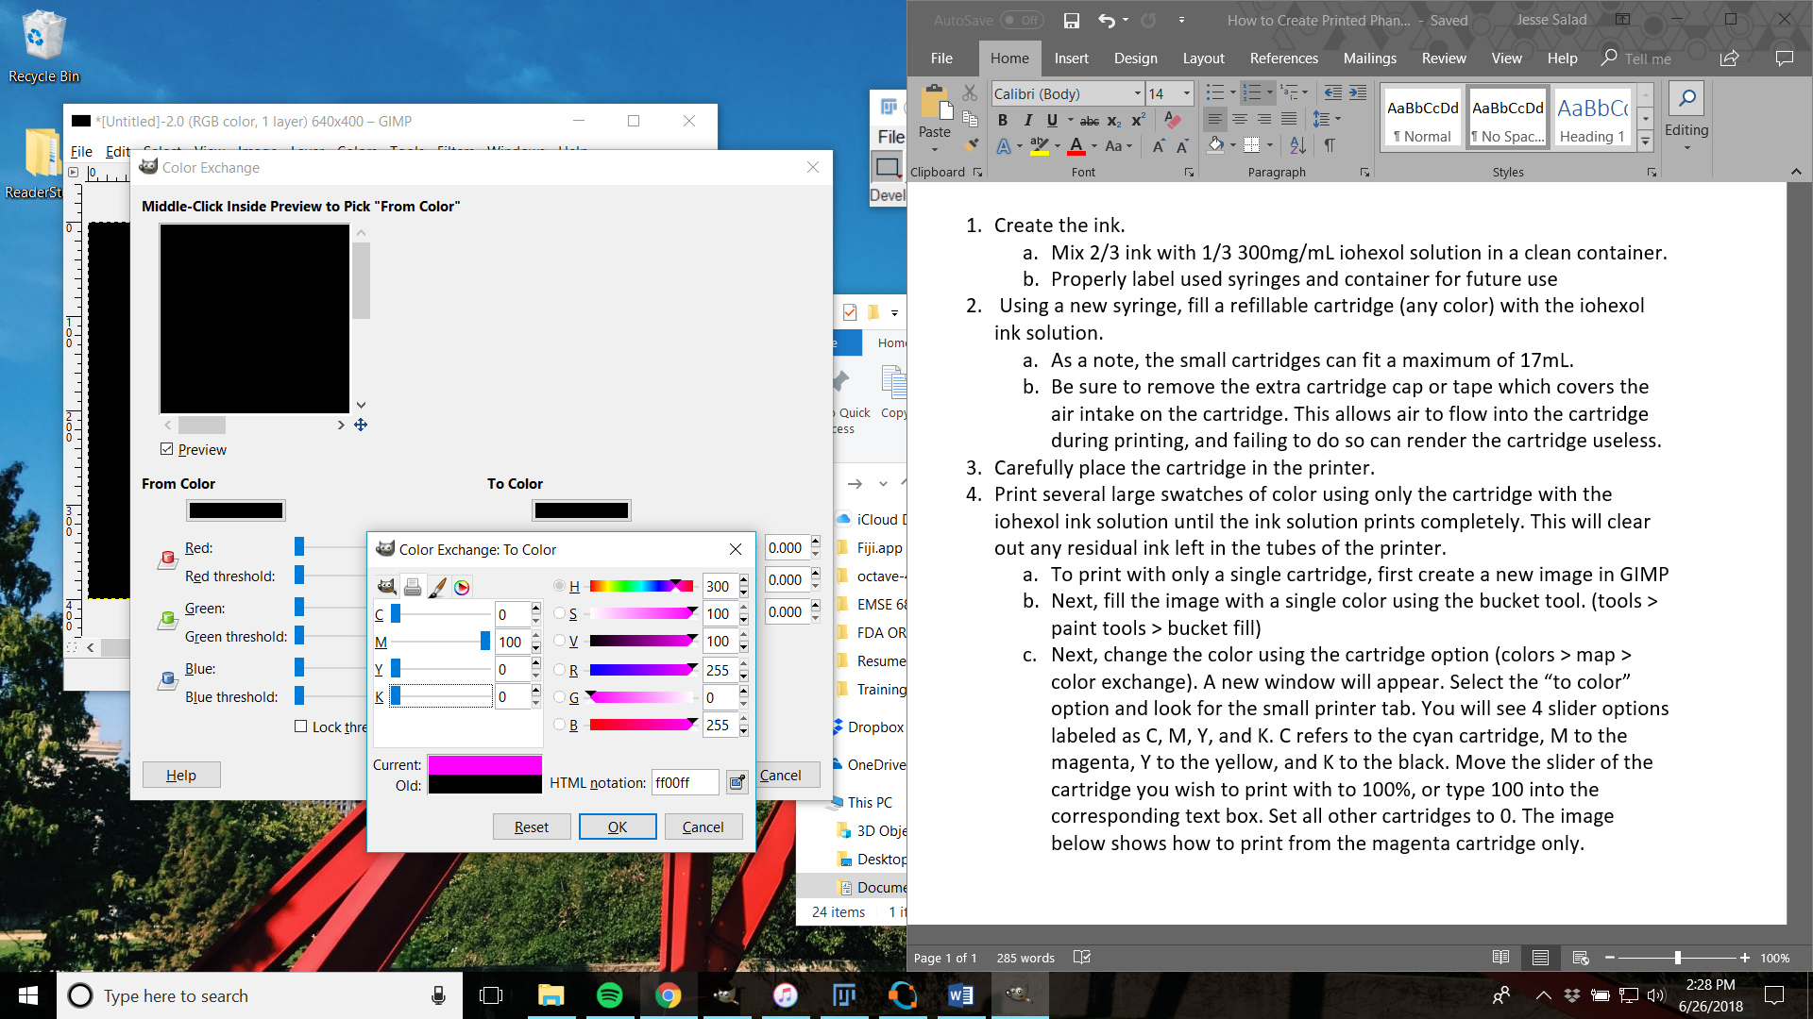Next, change the color using the cartridge option (colors > map > color exchange). A new window will appear. Select the “to color” option and look for the small printer tab. You will see 4 slider options labeled as C, M, Y, and K. C refers to the cyan cartridge, M to the magenta, Y to the yellow, and K to the black. Move the slider of the cartridge you wish to print with to 100%, or type 100 into the corresponding text box. Move all other cartridges to 0. The image above shows how to print from the magenta cartridge only.
   4. ***If printing with only a single color of ink, it may be easier to put the iohexol ink solution in the black cartridge as this color exchange step can be skipped, saving a lot of time.***
5. Once the residual ink has been cleared, the phantom printing can begin.
   1. Import the file to GIMP. The simplest way is to drag and drop the file into the GIMP user interface.
   2. Select the option to import the file as an “image”, and select the first slice
      1. *GIMP allows only one image to be imported at a time*
   3. If printing from the black cartridge, do not perform the color exchange, otherwise follow the instructions to exchange the color from step 4.
   4. Next, select the print option to bring up the printer option menu.
   5. Under image settings, choose the appropriate printing resolution. *See image below*
      1. This will depend on the voxel size of the breast file.

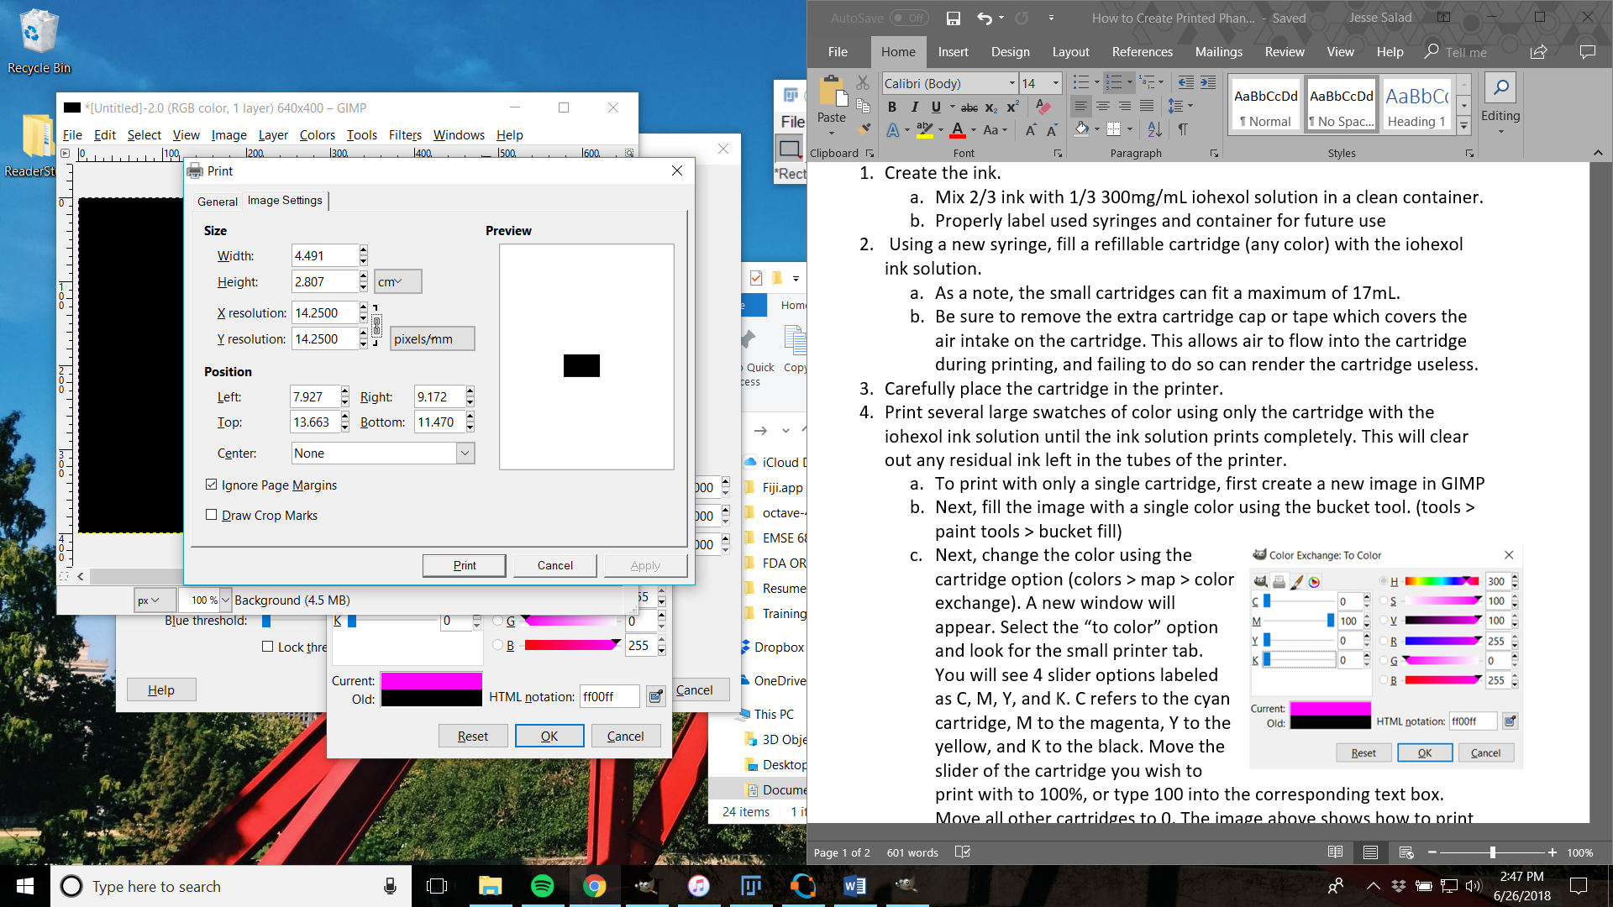

* 1. Under the general tab, select preferences, and change the printing quality to high. Also, if printing in color be sure to select color here, or grayscale if printing in black
  2. Print the slice

1. Check to see if the chosen printing resolution is appropriate
   1. This can be done by either punching holes through the fiducial markers and seeing if the slice fits on the phantom stand, or by measuring with a caliper. Doing both is recommended.
   2. If the slice is not appropriately sized, repeat step 5(e) and reprint. Repeat until an appropriate resolution is found.
2. Repeat the printing process for each slice of the phantom.
   1. As a note, previous selections of printing preferences and image settings should be saved between image imports.
3. Hang the slices as they print to dry, and leave for at least 24 hours.
4. Punch holes through the fiducial markers, and place in order on the phantom stand.

When creating the insert, ensure that the lesions and background have different gray level values. Usually set the background to a lower value by dividing or subtracting some value from the stack in ImageJ. In Gimp you can then select those regions and set which cartridge you want to print from for that gray level, and what percentage of ink (78% for the lesions).

For the glandular regions, we only use iohexol ink in a ratio of 1/3 iohexol to 2/3 ink. The iohexol has a concentration of 300mg/mL, so the final solution contains 100mg/mL of iohexol.

For the lesions, we’ve used 300mg/mL KI and 600 mg/mL KI solutions. The first is created by dissolving the appropriate amount of KI in a mixture of 2/3 water and 1/3 ink. For example, we would dissolve 4.5g of KI in a solution of 10mL water / 5mL of ink. The second uses 1/3water and 2/3 ink.